**Name: Kapil Shrestha**

**Roll no: 28**

**Project title: My - whiteboard**

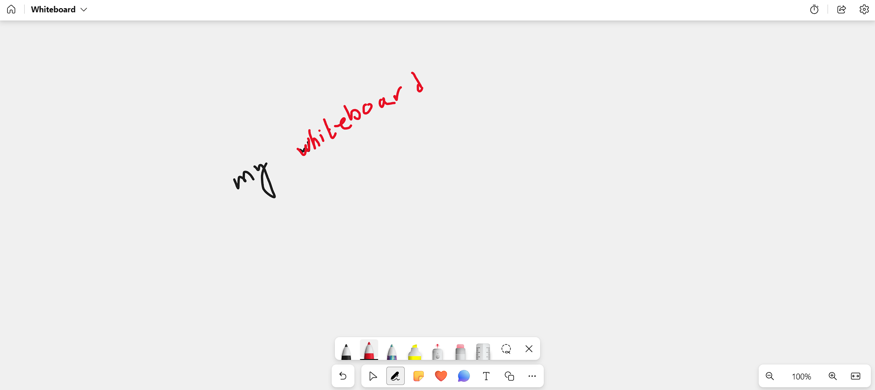

**Features:**

Enable user write using pens of multiple color and multiple sizes.

Can erase the whole whiteboard and certain portion of whiteboard using eraser tool.

Can make different shapes (lines / circle / rectangle)

Can select, drag the drawn section

Can zoom in and out the selected section

**Additional features:**

Zoom in and zoom out the whiteboard.

Adding multiple whiteboard.

Edit and save features